**PDA Evidence - Chris Burn, G2 Cohort**

**Week 2:**

*Demonstrate the use of an array in a program. Take screenshots of:*

*\*An array in a program*

*\*A function that uses the array*

Two Arrays or strings, pulled into “add_length_of_arrays” method

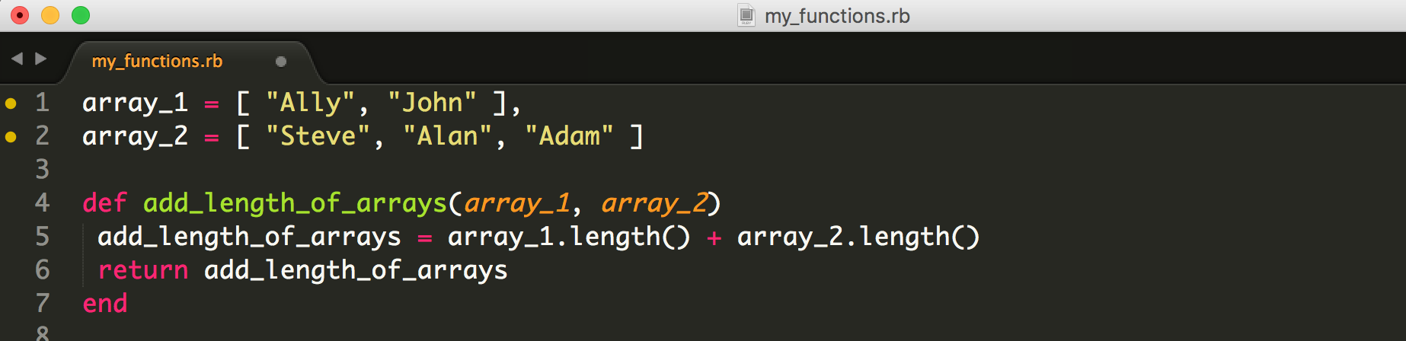

*\*The result of the function running*

Shows TDD testing of method through MiniTest and result of MiniTest in Terminal...

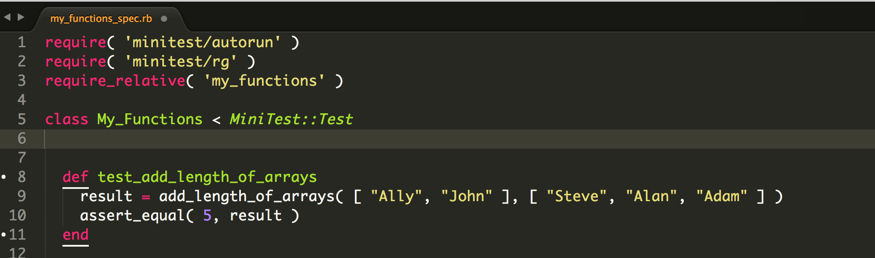

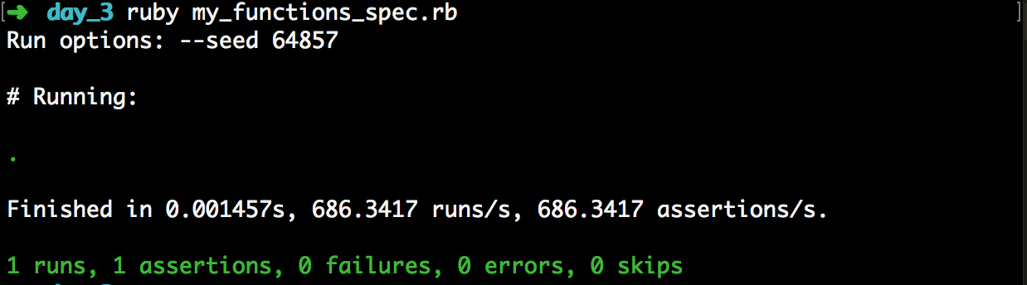

*Demonstrate the use of a hash in a program. Take screenshots of:*

*\*A hash in a program*

*WITH*

*\*The result of the function running*

Hash and an Array with in-built Hashes, WITH testing of function (separate) via MiniTest

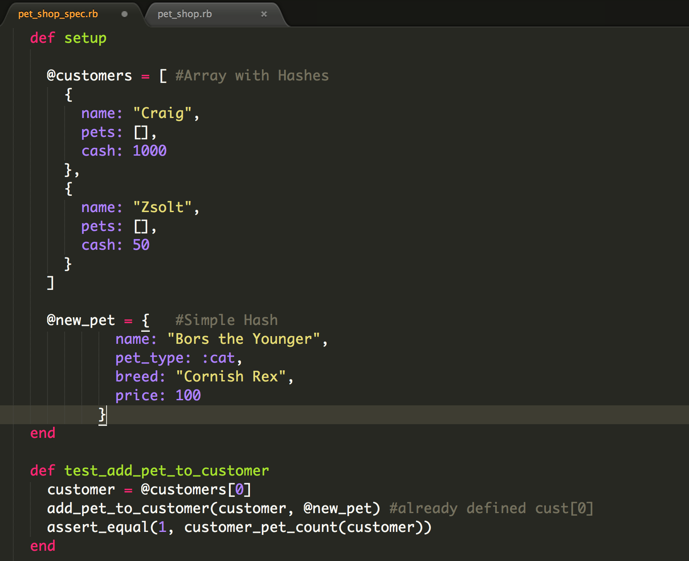

*\*A function that uses the hash*

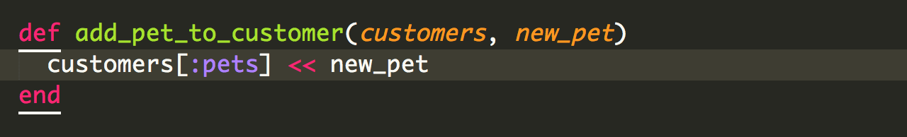

**Week 3:**

**Demonstrate searching data in a program. Take screenshots of:**

**\*Function that searches data**

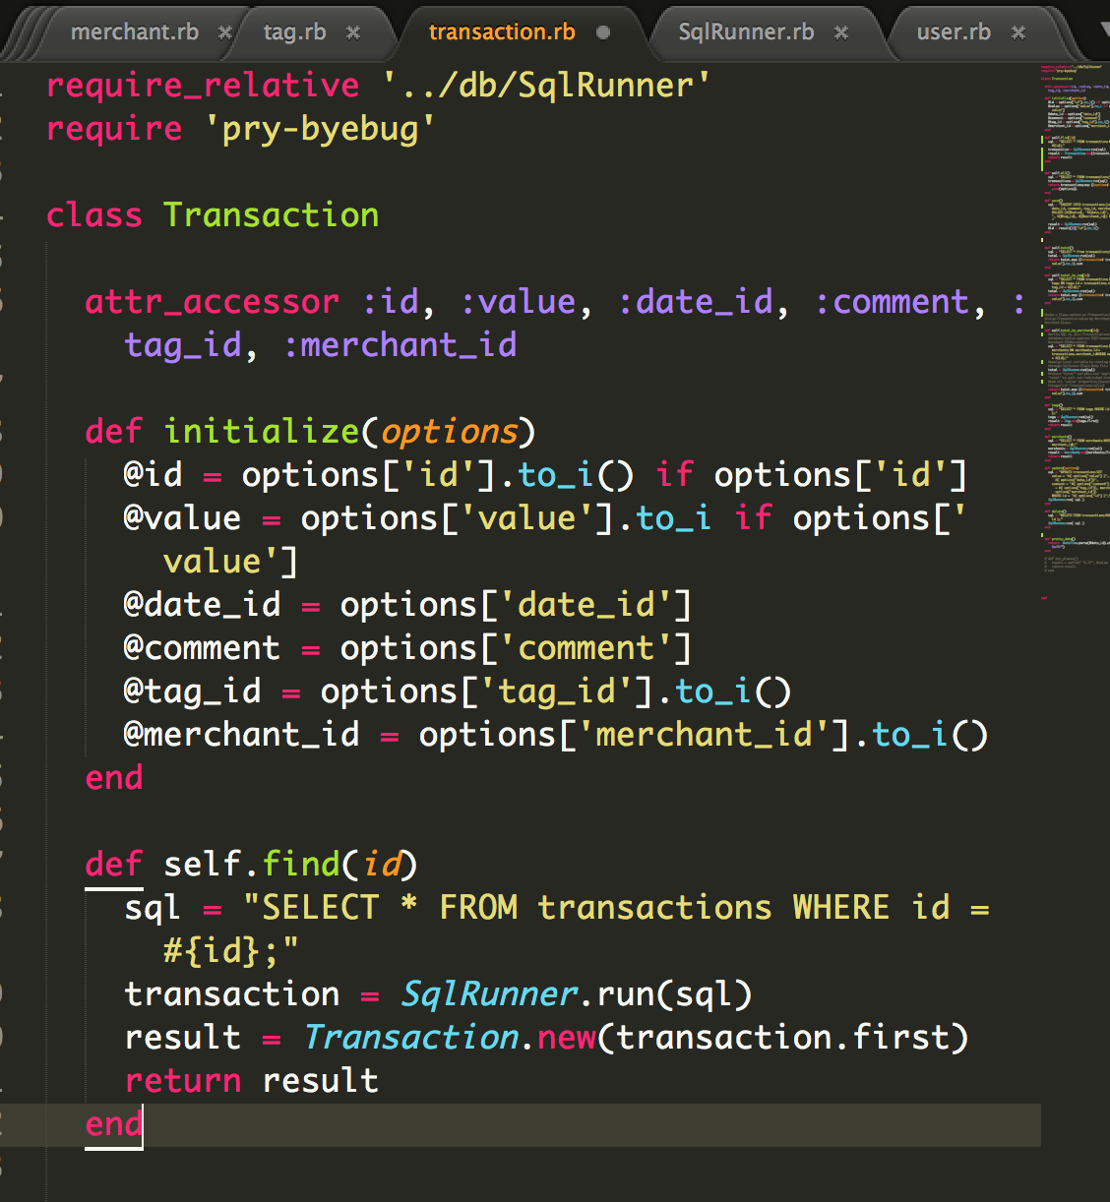

**\*The result of the function running**

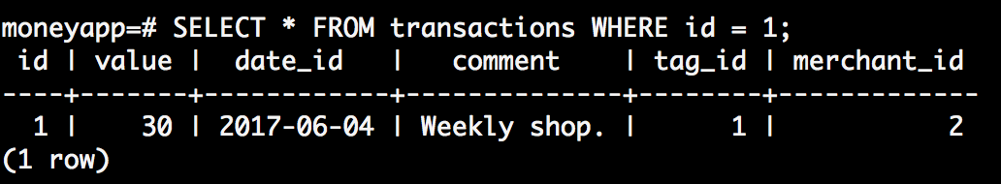

**Demonstrate sorting data in a program. Take screenshots of:**

**\*Function that sorts data**

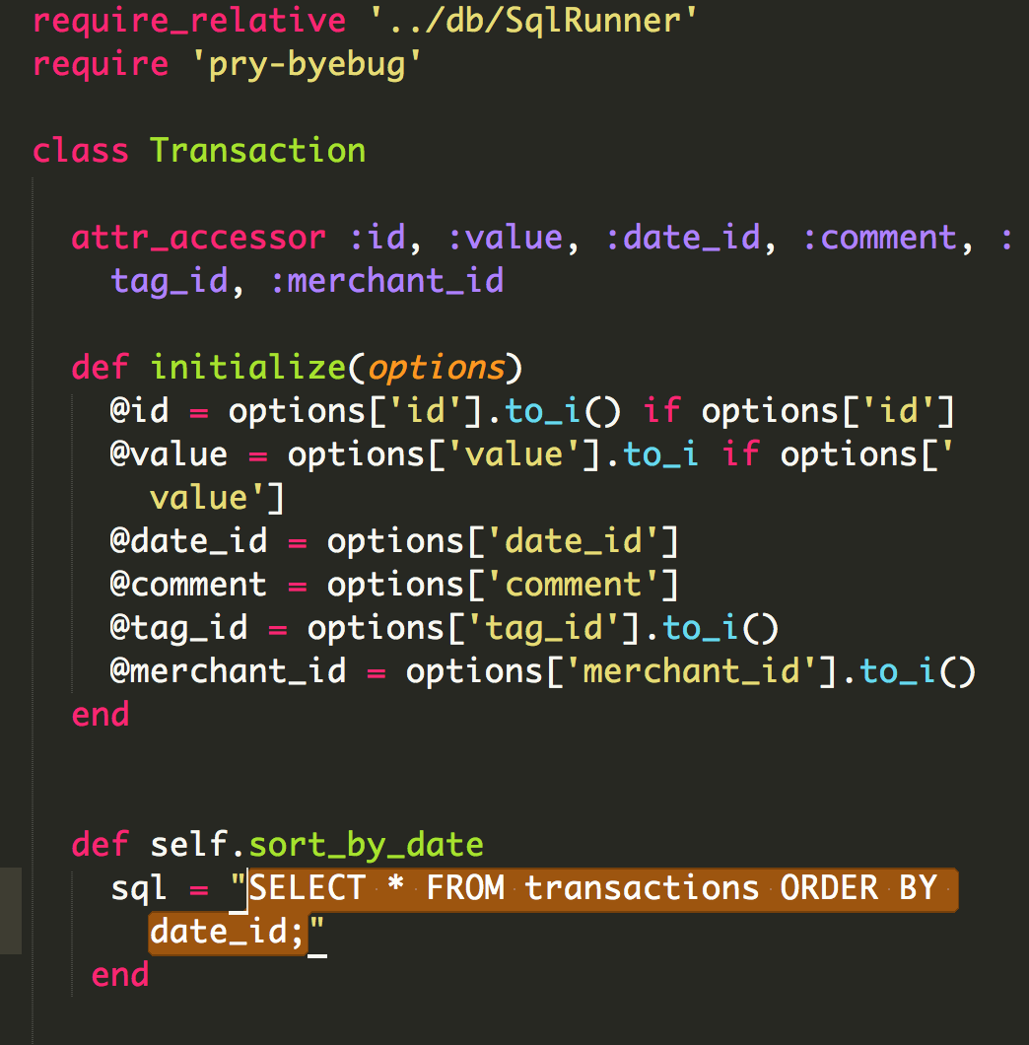

**\*The result of the function running**

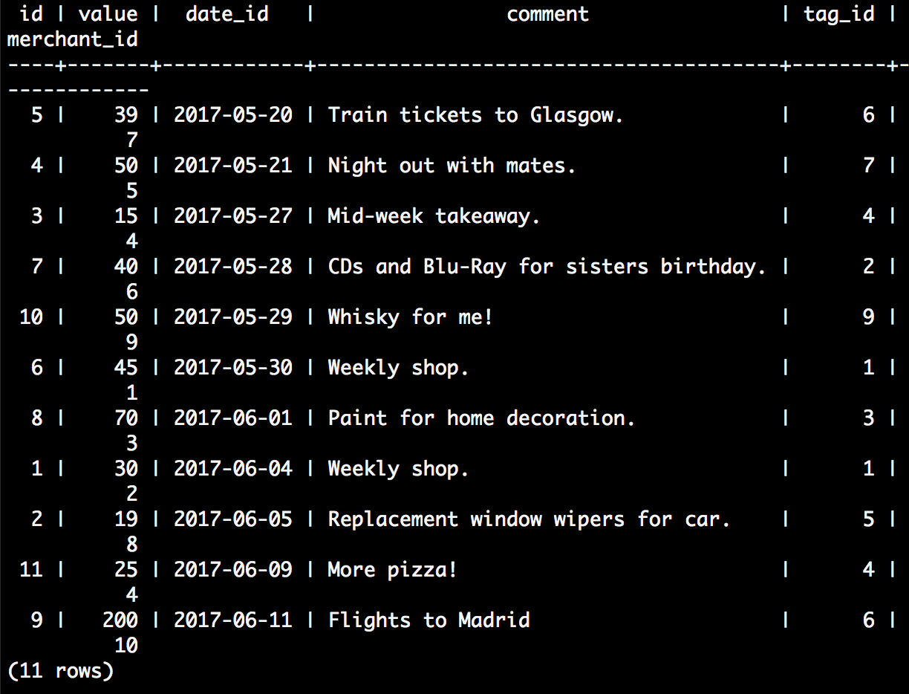

**Week 5:**

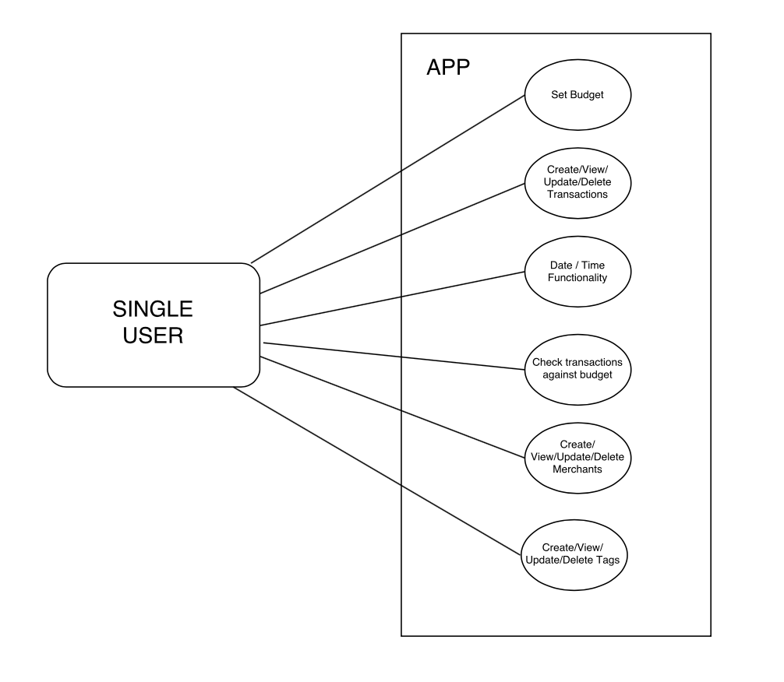

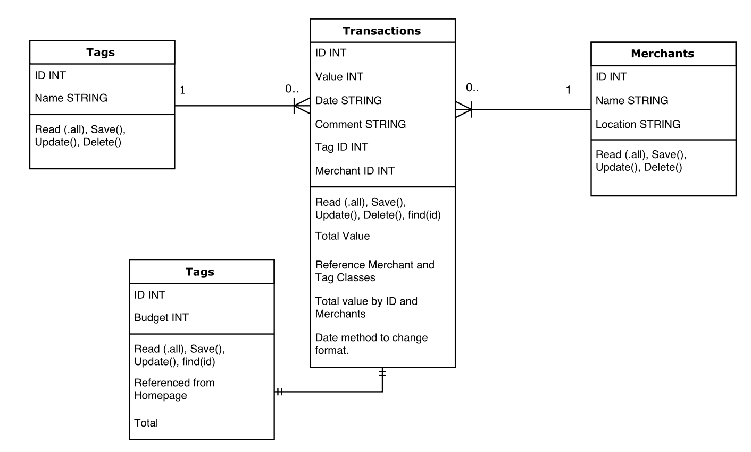

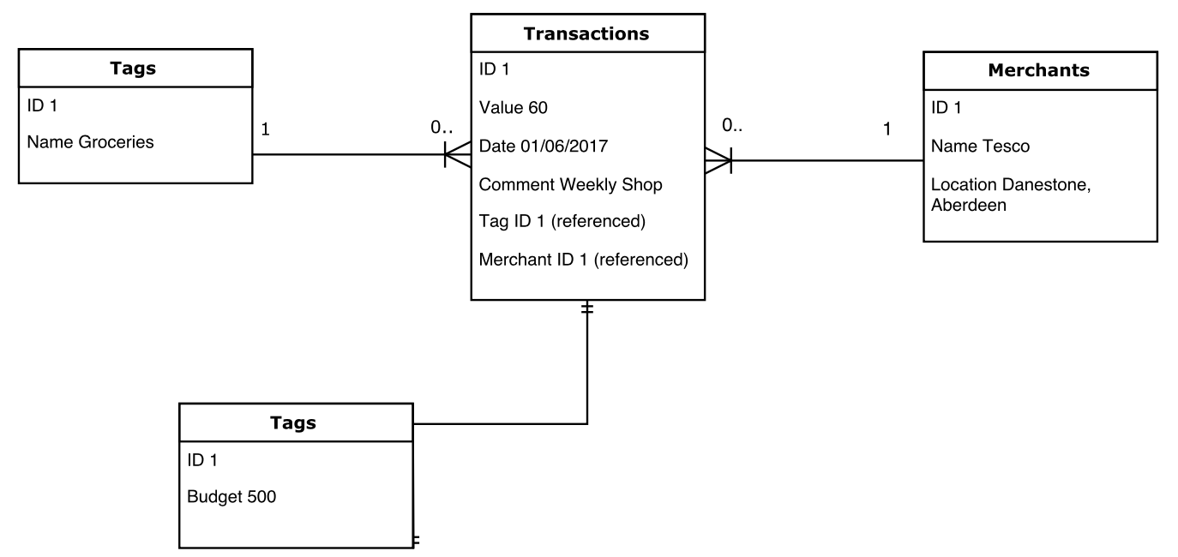

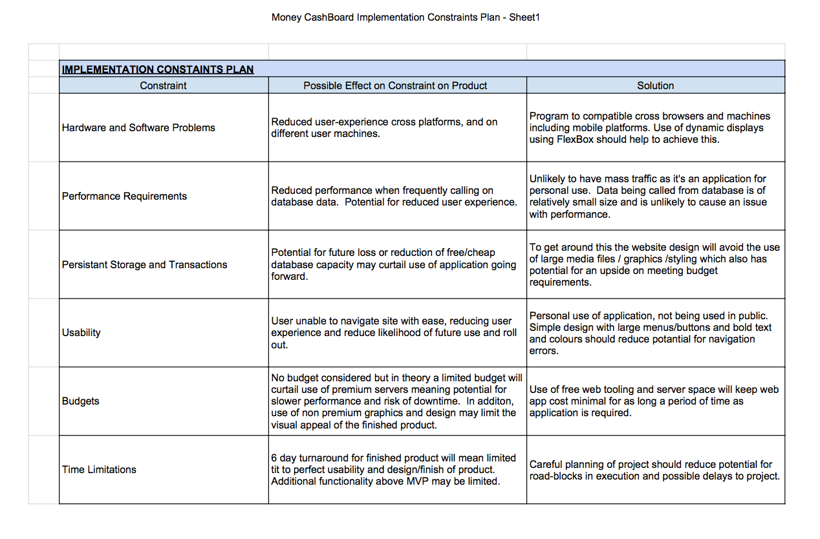

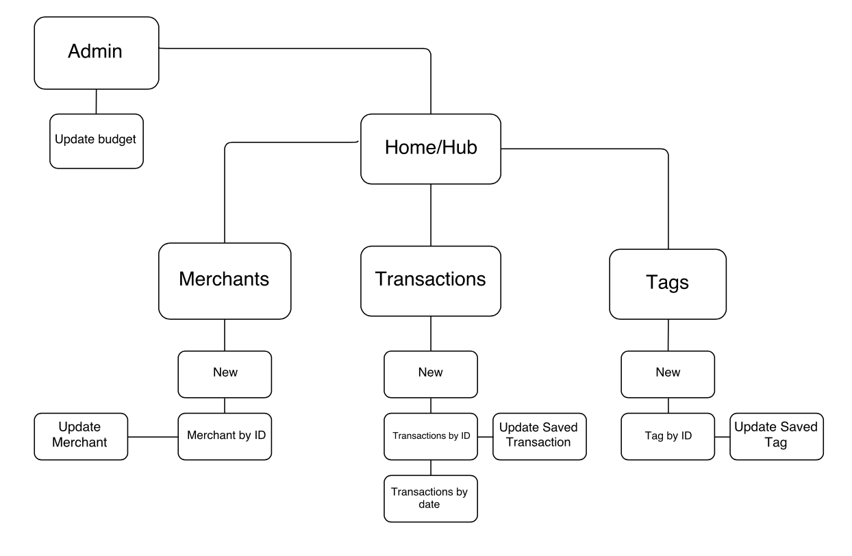

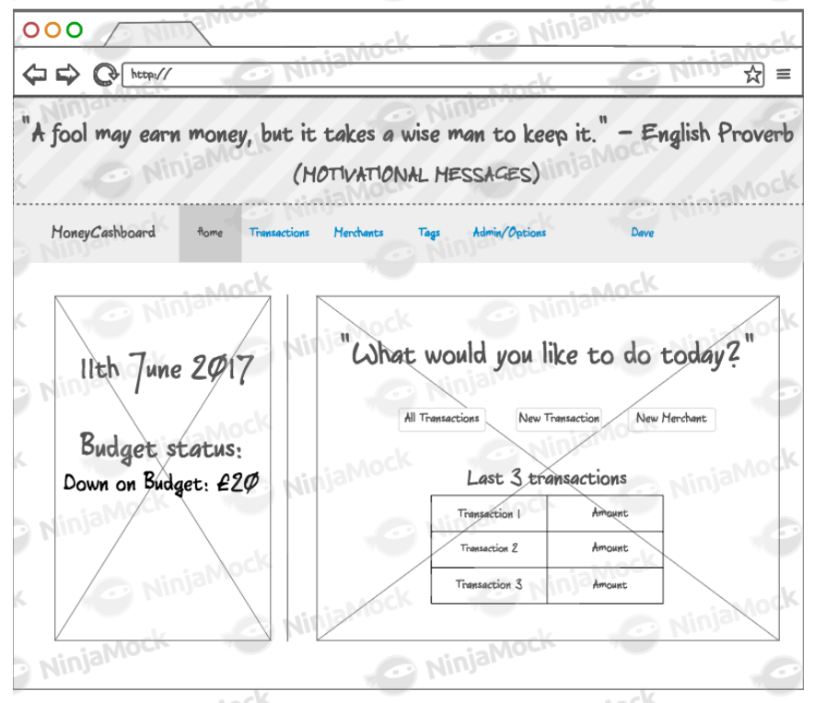

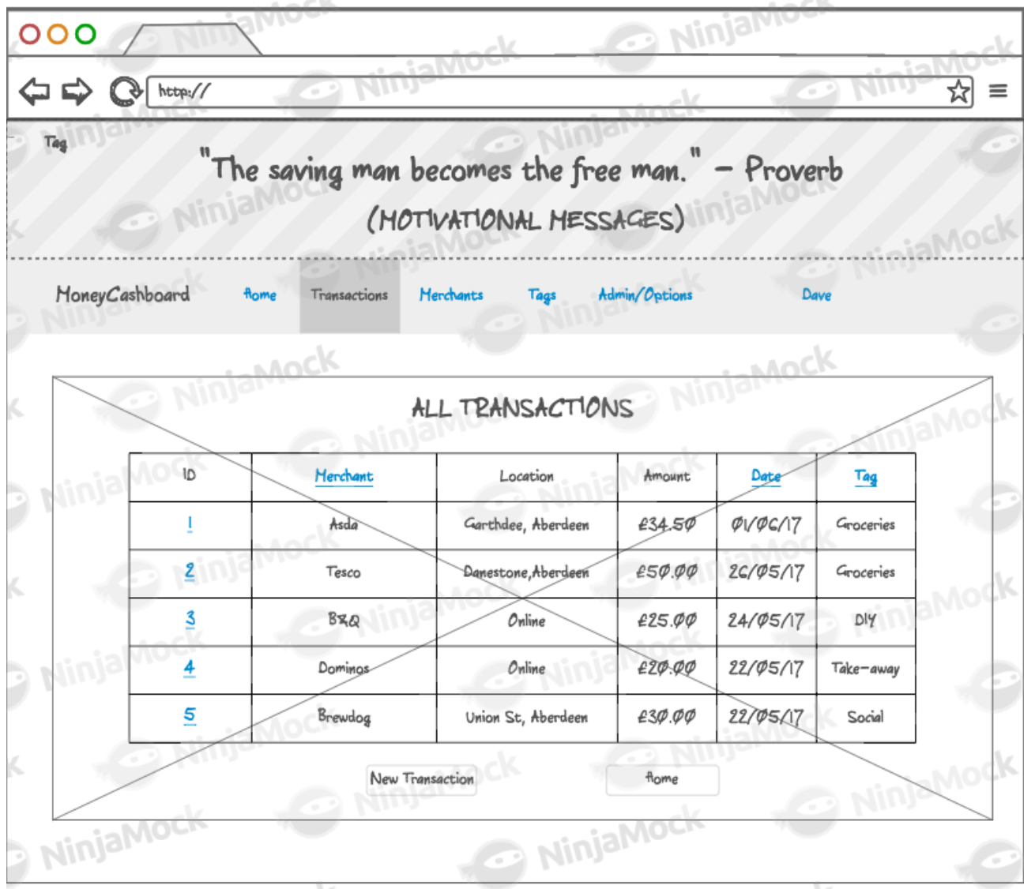

Psudo-code example showing a method calling on the result of an INNER JOIN on two database tables:

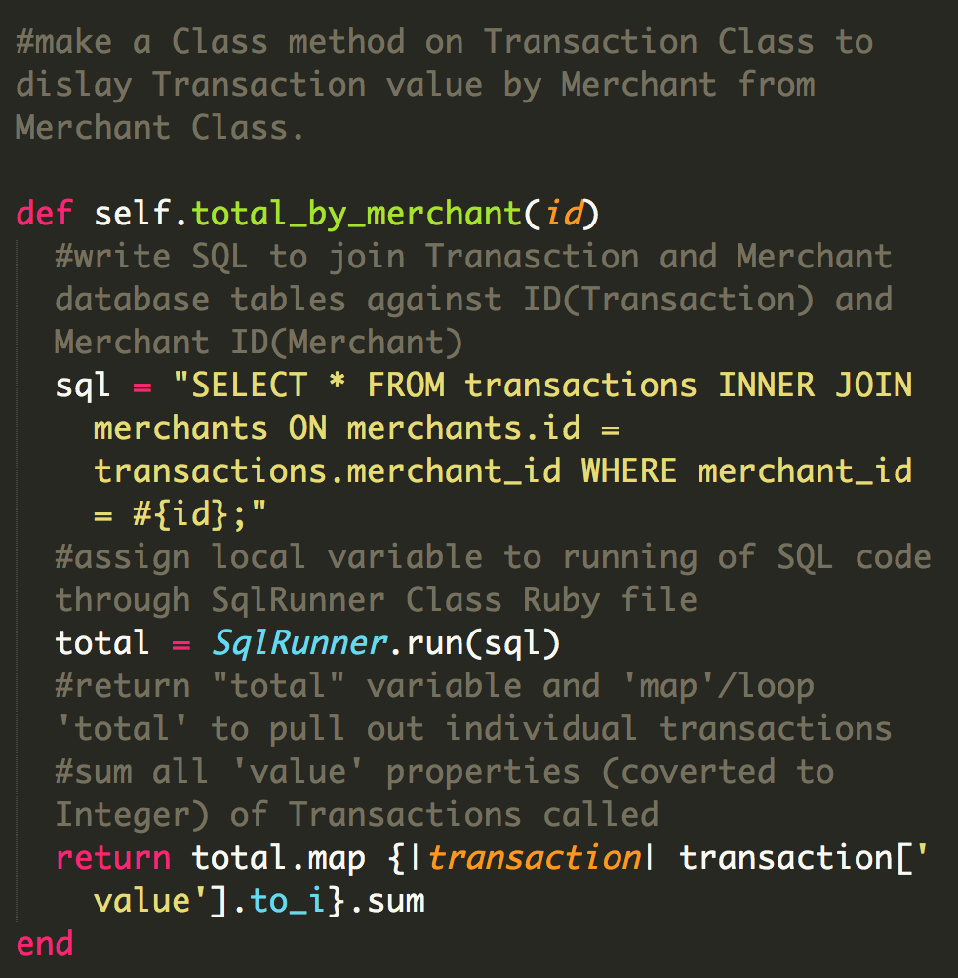

**Show user input being processed according to design requirements. Take a screenshot of:**

* The user inputting something into your program

* The user input being saved or used in some way

**Show an interaction with data persistence. Take a screenshot of:**

* Data being inputted into your program

* Confirmation of the data being saved

**Show the correct output of results and feedback to user. Take a screenshot of:**

* The user requesting information or an action to be performed

* The user request being processed correctly and demonstrated in the program

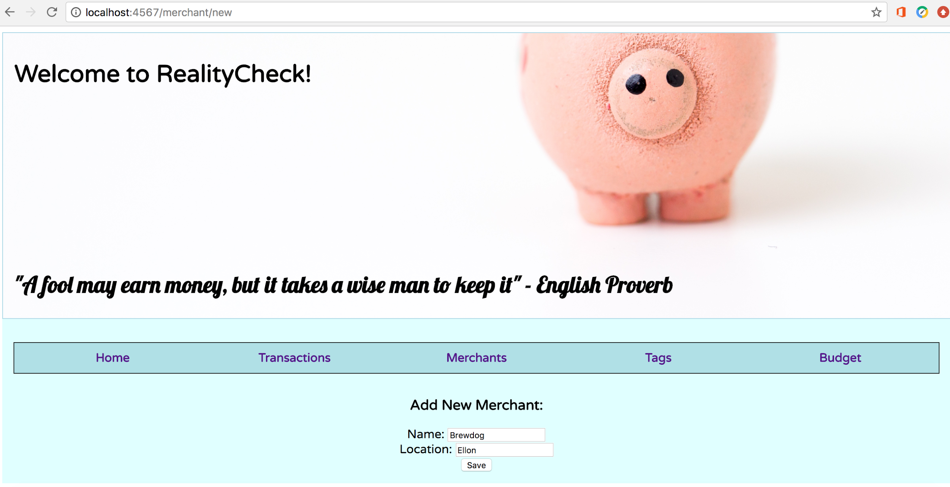

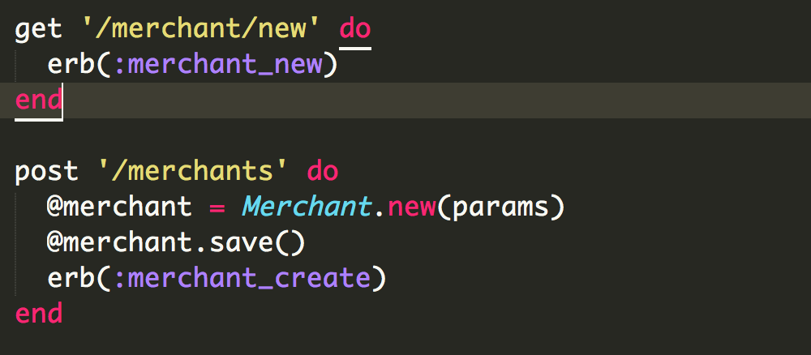

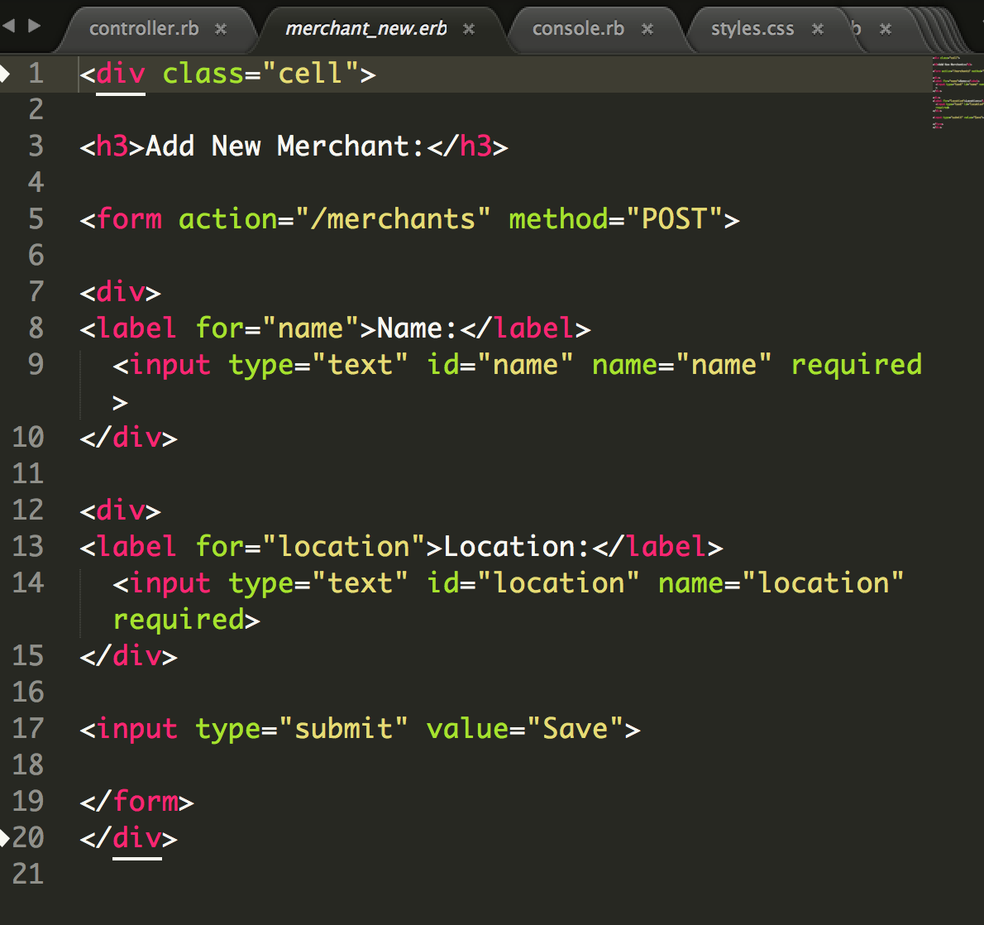

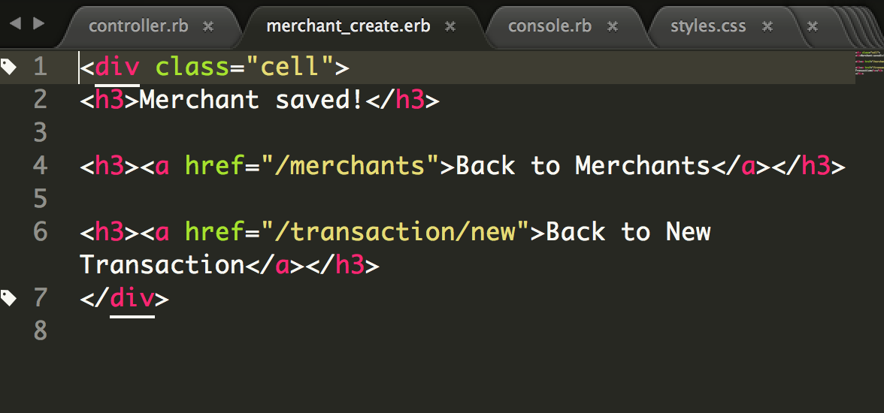

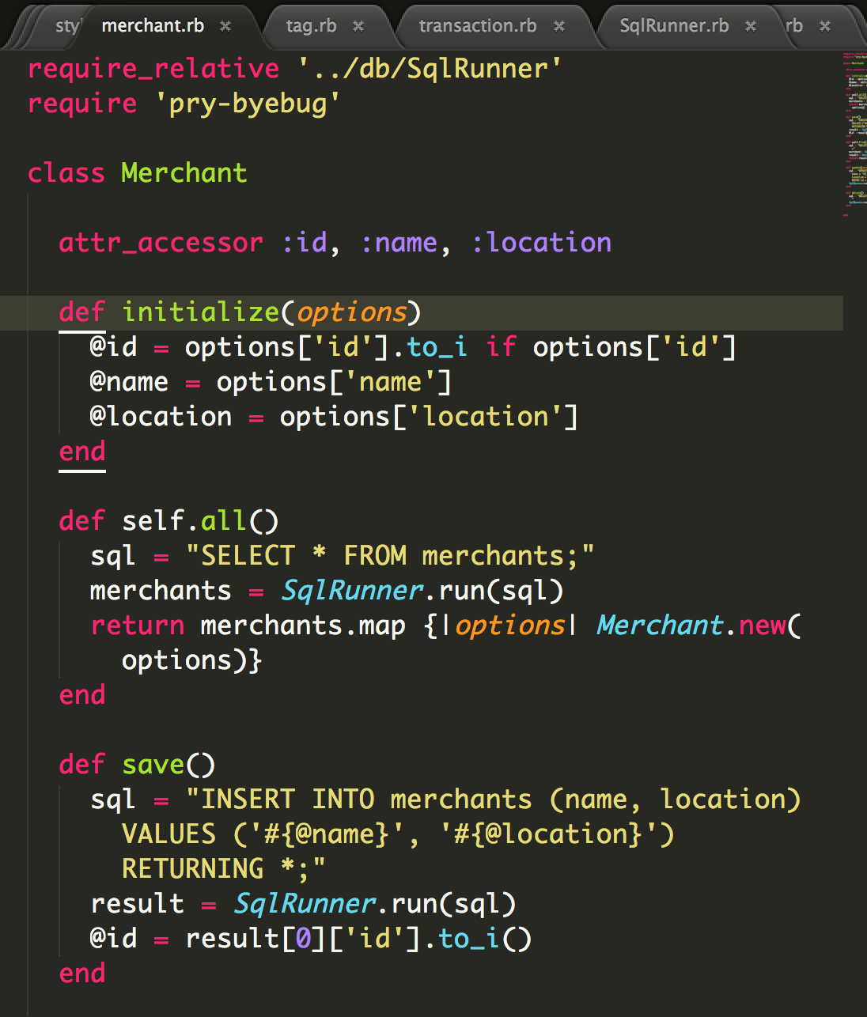

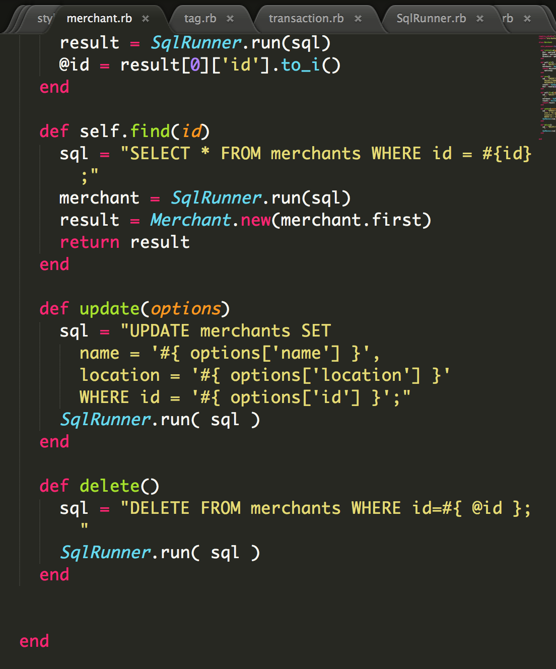

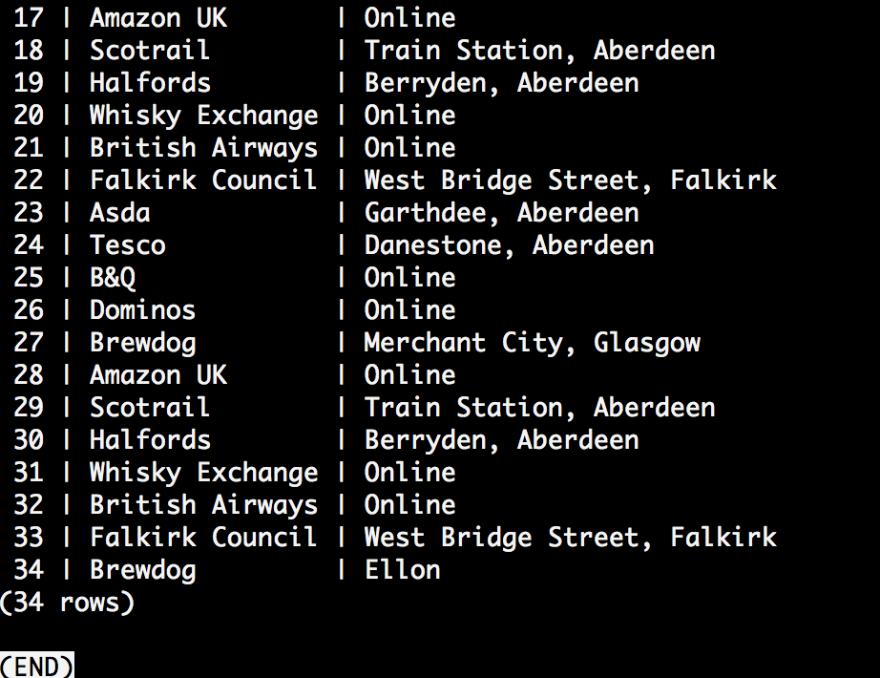

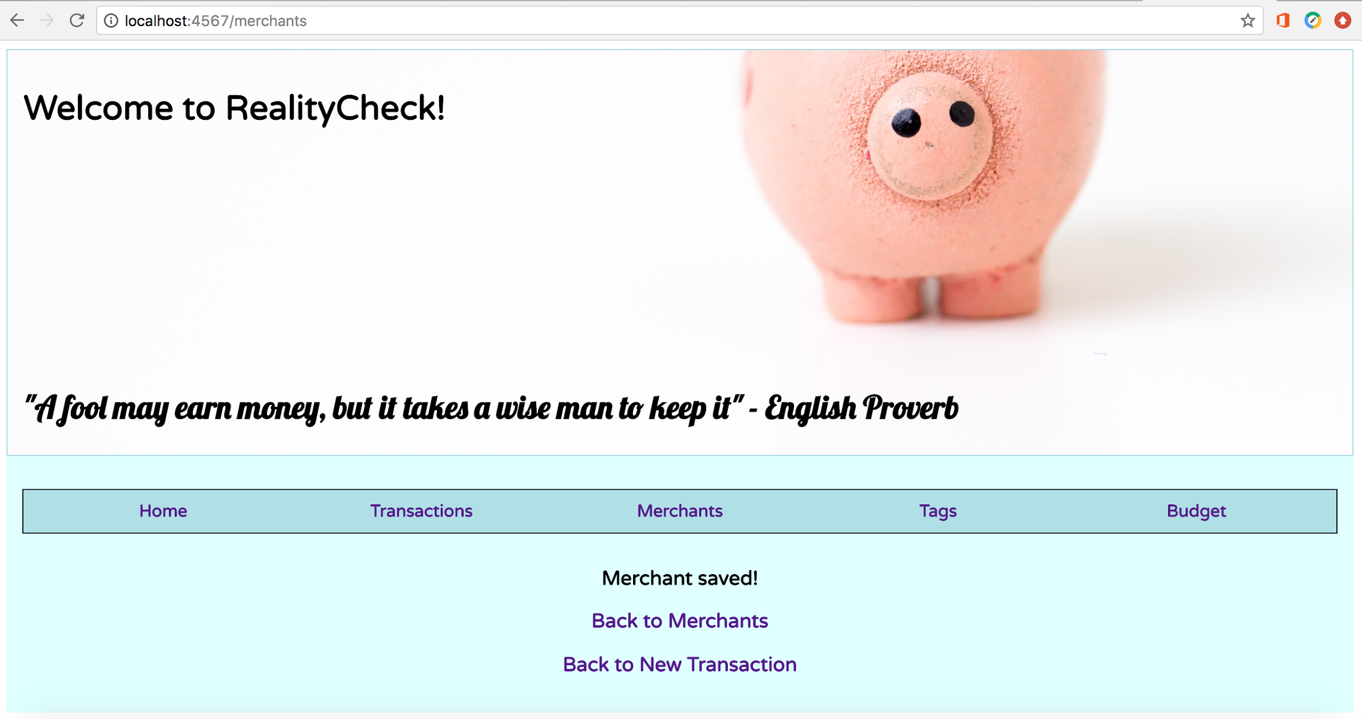

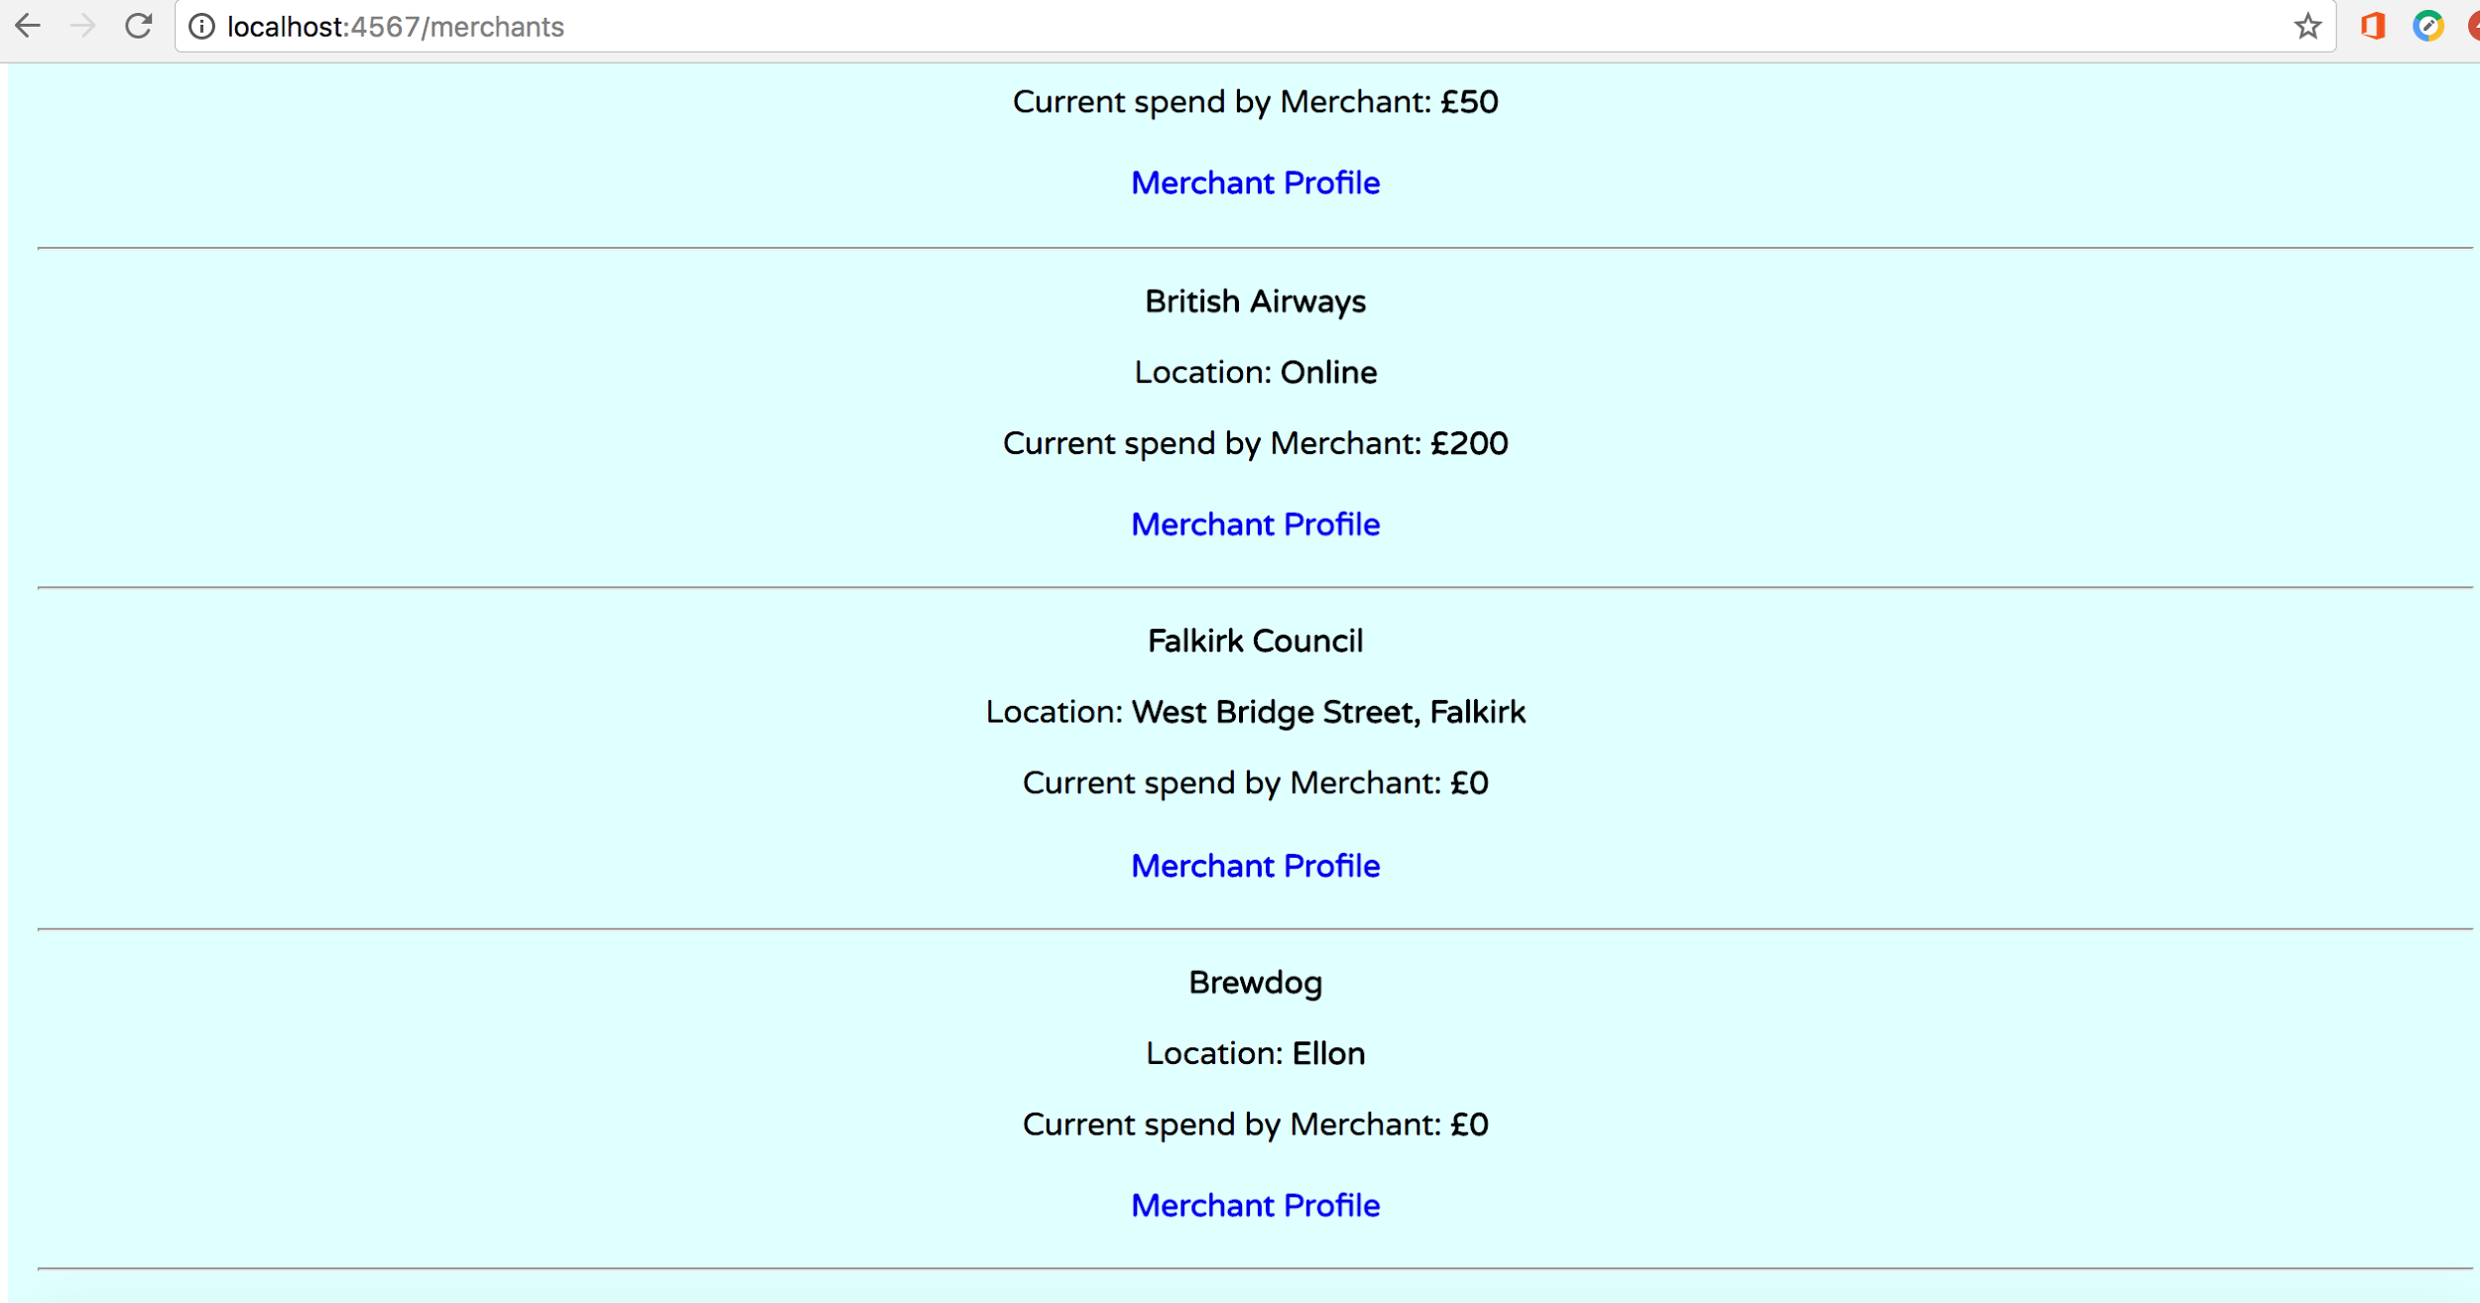

**Week 6:**  
  
Demonstrate the use of Polymorphism in a program:  
POLYMORPHISM

- Capacity to take on different forms.

- A language’s ability to process objects of various types and classes through a single, uniform interface.

- Example, how a parent class refers to a child class object

- Any object that satisifies more than one IS-A relationship is polymorphic in nature.

- Fair to say that every Object in Java is polymorphic in nature, each on passes IS-A test for itself and for Object class.

E.g. Animal class, Cat IS sub-class of Animal. Cat satisfies IS-A relationship of own type and its Super-class, Animal.

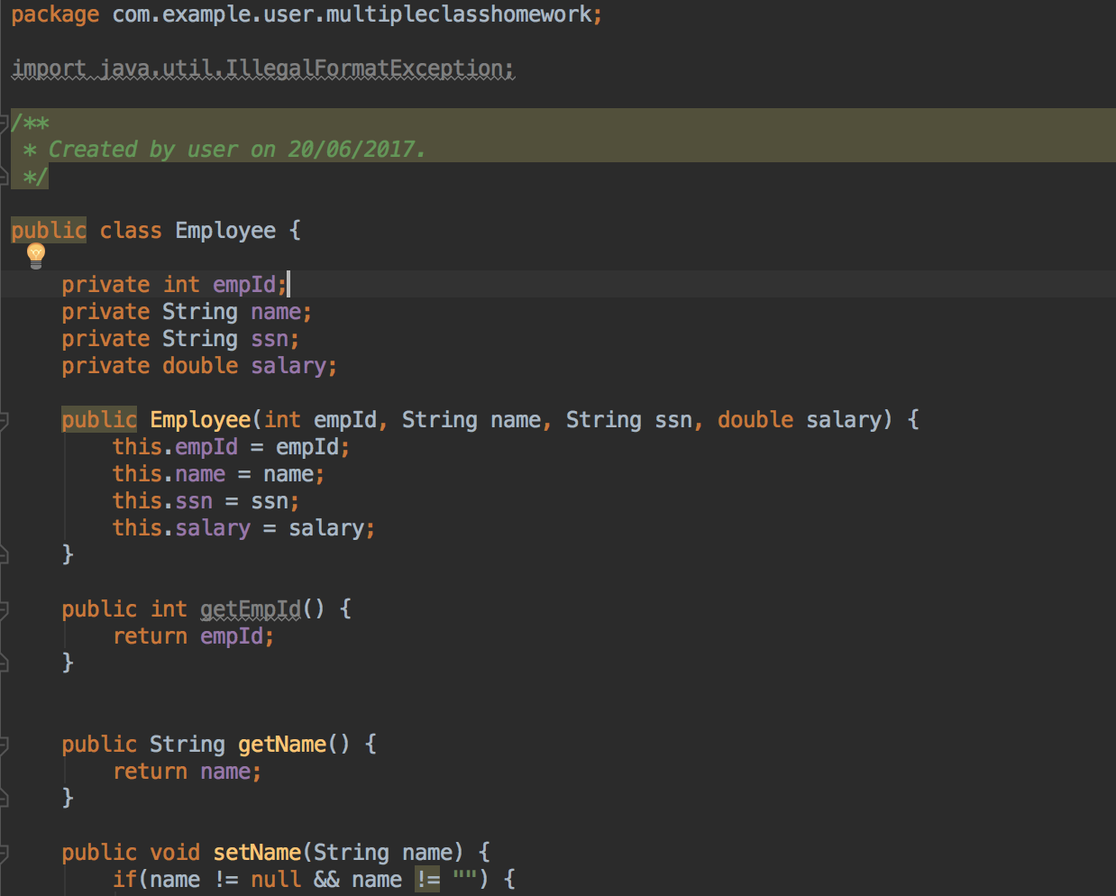

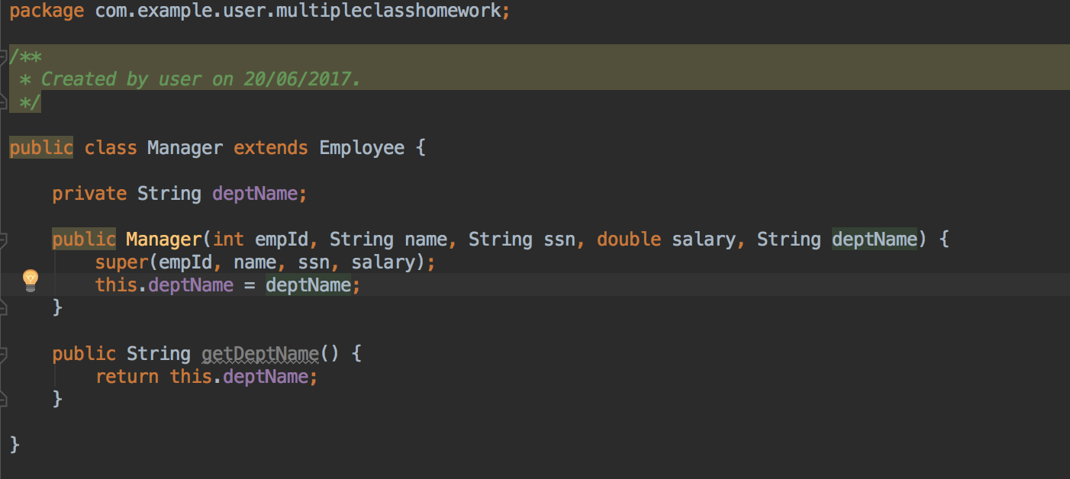

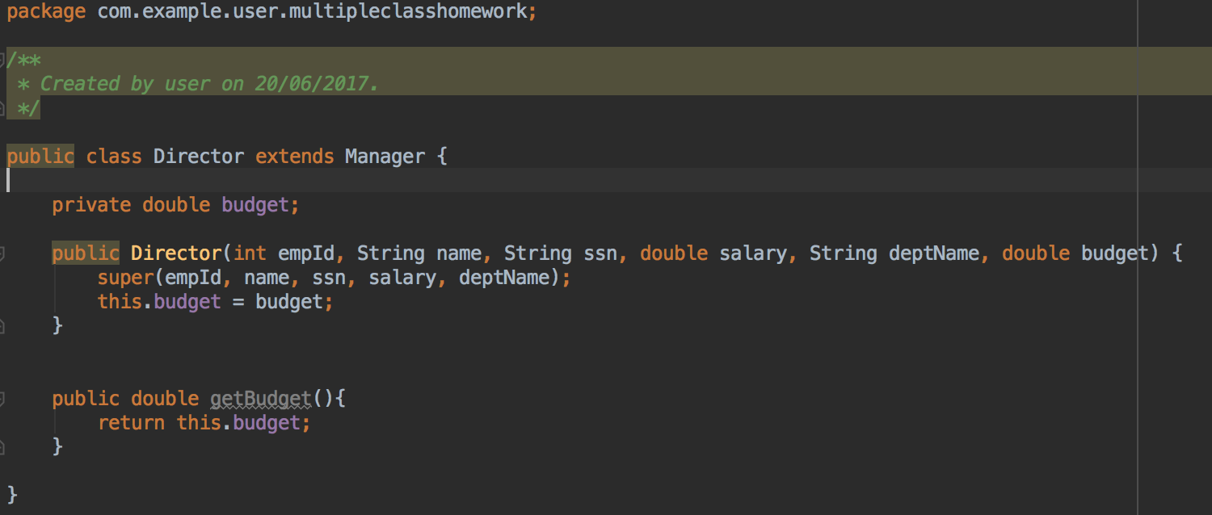

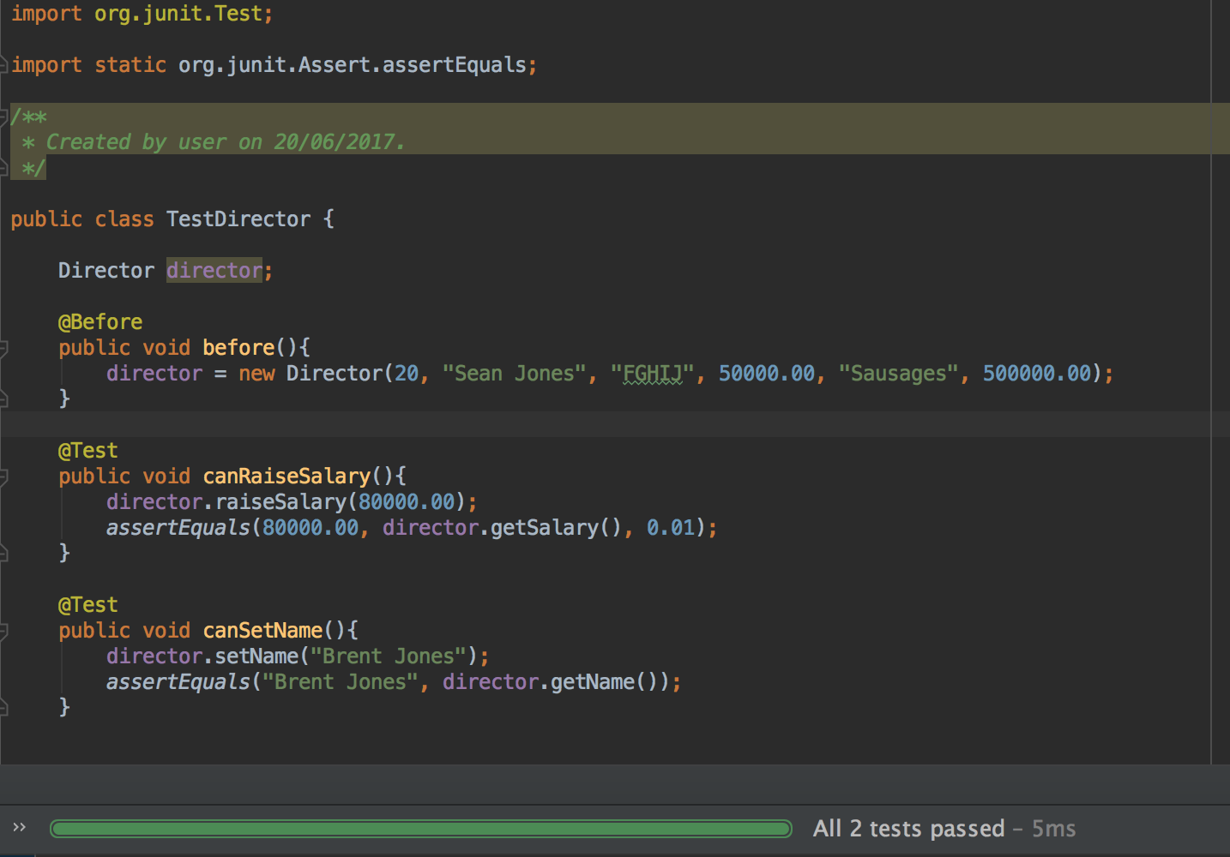

**Week 7:**  
*An Inheritance Diagram*  
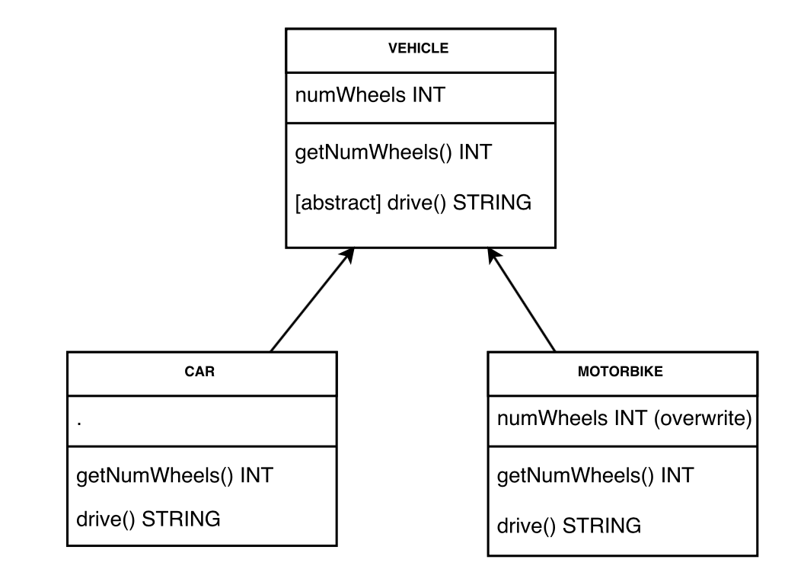

*Take a screenshot of an example of encapsulation in a program*

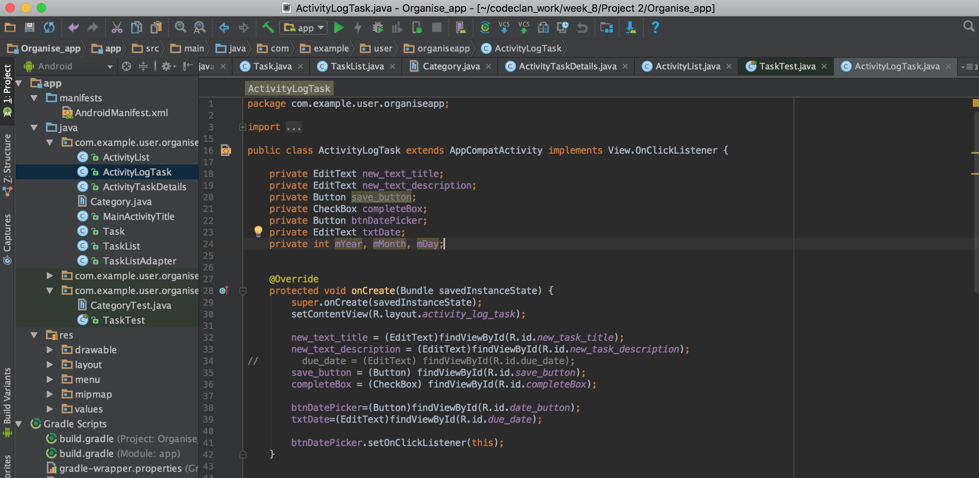

*Take a screenshot of the use of Inheritance in a program. Take screenshots of:   
*A Class  
*A Class that inherits from the previous class  
*An Object in the inherited class  
*A Method that uses the information inherited from another class.*

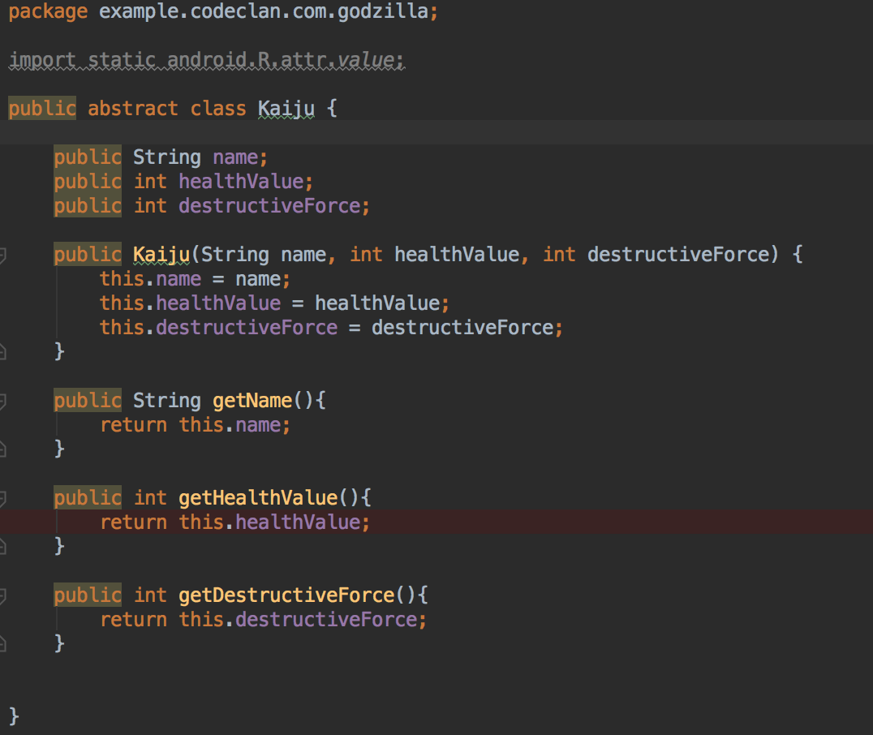

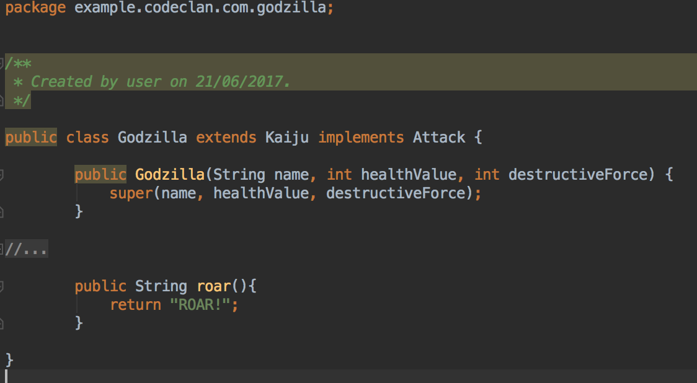

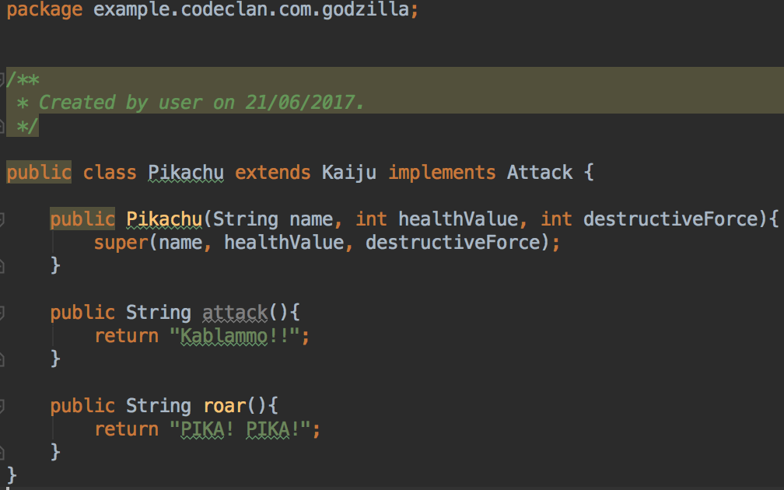

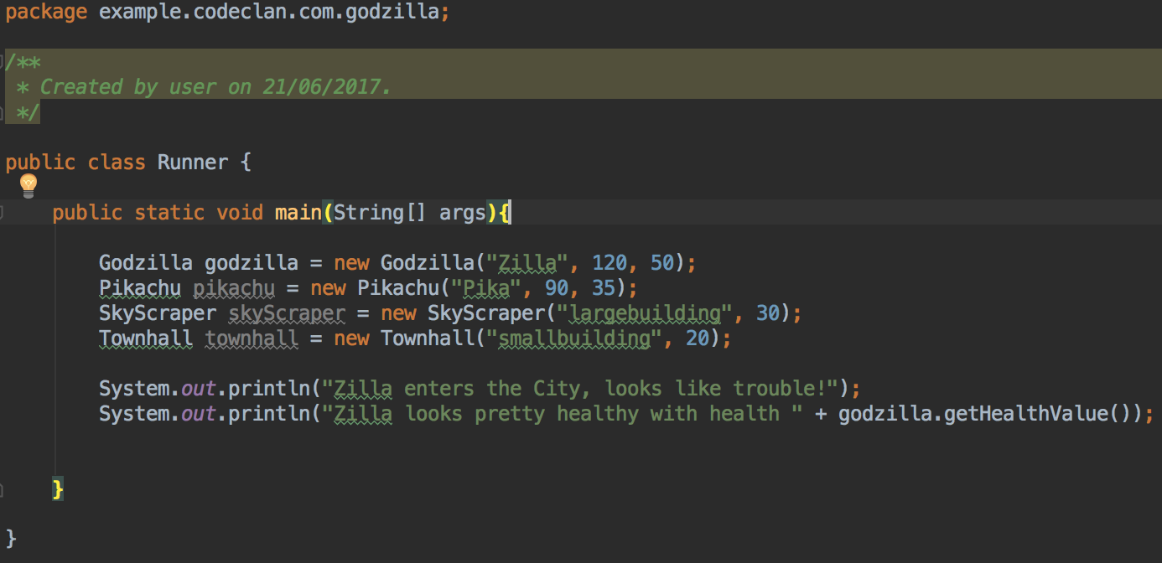

*Take a screenshot of one of your projects where you have worked alone and attach the Github link.*

<https://github.com/chris-burn/To-Do_list_project>

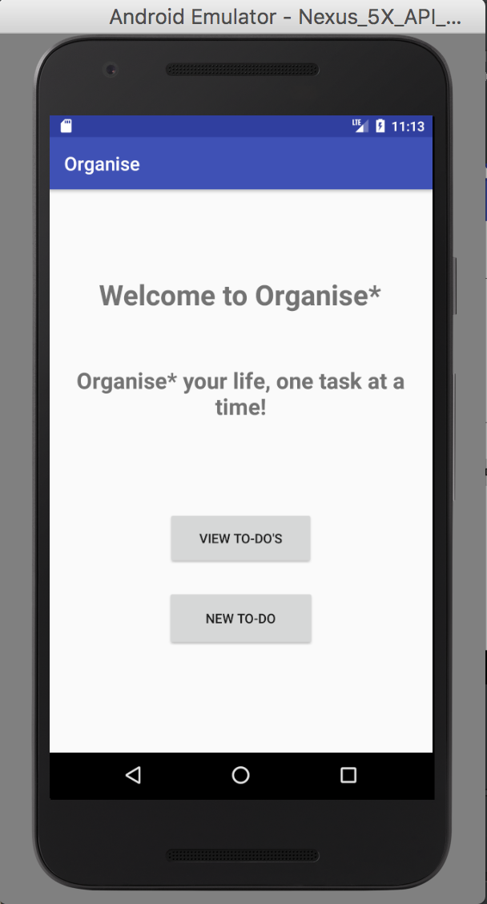 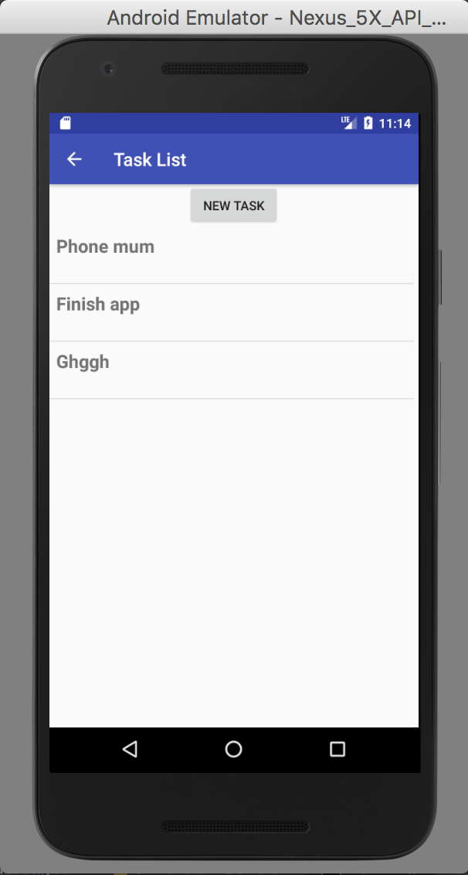 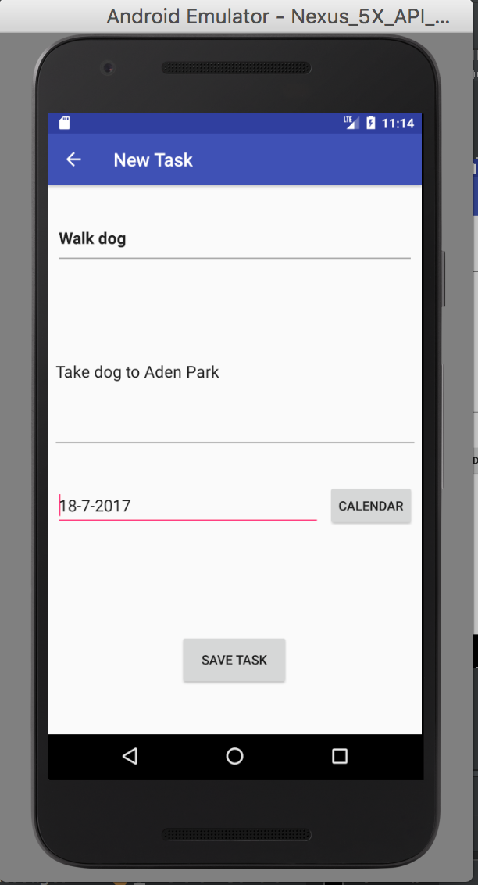

Take screenshots or photos of your planning and the different stages of development to show changes.

Android App, PROJECT PLANNING:

